Vintage Lounge Chair

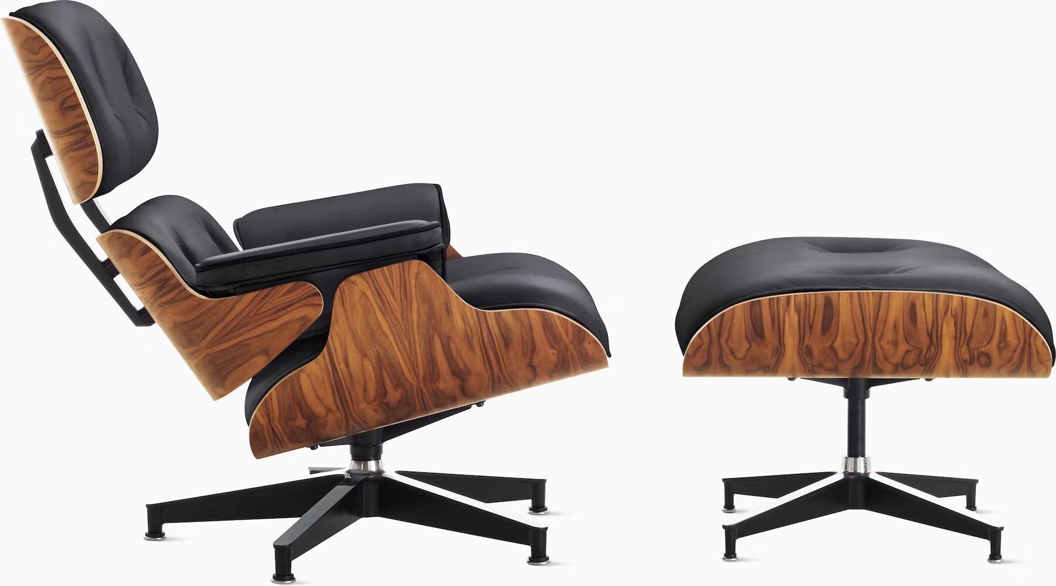

This classic lounge chair was designed by Charles and Ray Eames and features a molded plywood shell, leather upholstery, and a sleek aluminum base.